Endoparasites
What is an endoparasite?
__________________________________________________________________________________

Name the 4 common types of worms found in dogs in the UK.
1.
2.
3.
4.

Label these parts of a tapeworm
Head enlarged
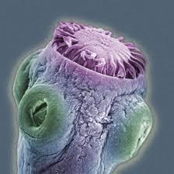
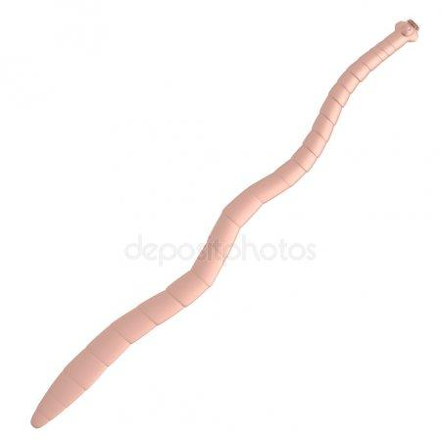

What personal protective equipment should you use to handle an animal that you suspect has tapeworms?
________________________________________________________________________________________________________________________________________________________________________________________________________________________________________________________________________________________________________________________________________
What organism does a cat or dog ingest, in order to become infected by a tapeworm?
_____________________________________________________________________

What is the name of the rabbit tapeworm and what symptoms would you expect to see in a severe infestation?
__________________________________________________________________________________________________________________________________________________________________________________________________________________________________________________________________________________________________________________________________________________________________________________________________________________________

What are the symptoms of tapeworms in dogs and cats? You should be able to list 8 symptoms.
1.
2.
3.
4.
5.
6.
7.
8.
What are these and what do they tell you about the animal the faeces came from?
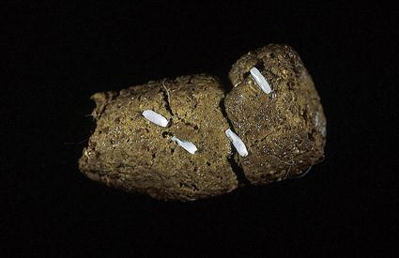
___________________________________________
___________________________________________
___________________________________________
___________________________________________
What advice would you give the owner of the animal, whose faeces are above?
______________________________________________________________________________________________________________________________________________________________________________________________________________________________________________________
Roundworms
What are the symptoms of roundworms?
1.
2.
3.
4.
5.
6.
7.

Why would you suspect that these puppies have round worms? What other clues would you look for?
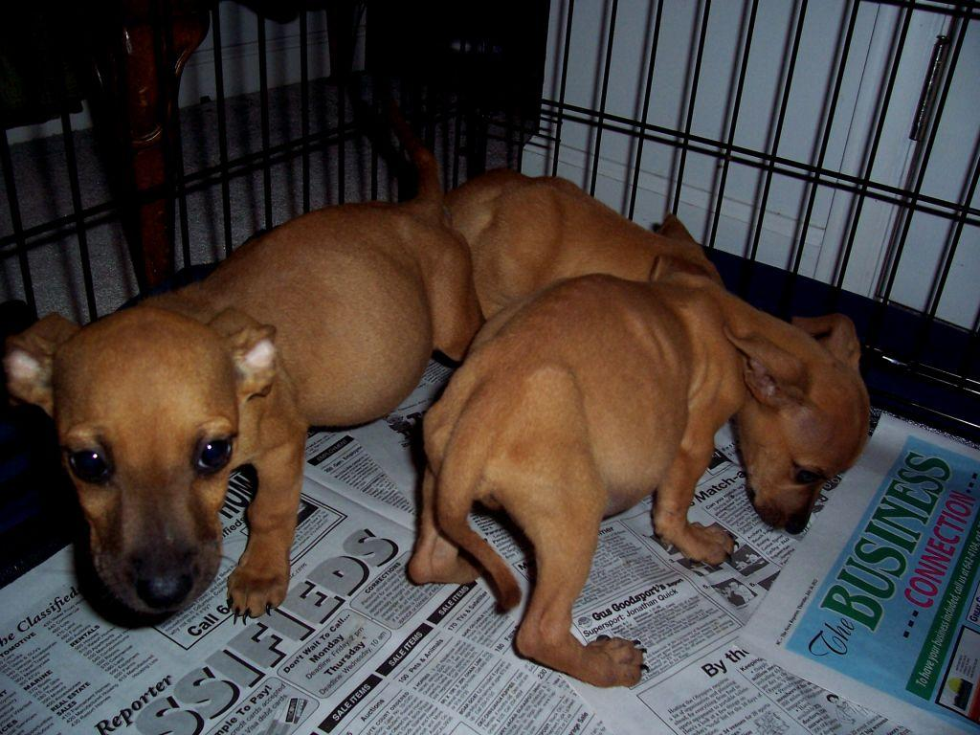
__________________________________________________________________________________________________________________________________________________________________________________________________________________________________________
What is an egg count and who would carry one out? ____________________________________________________________________________________________________________________________________________________________________

Scenario questions

Jacqui had bought a kitten for company. When she cleans the litter tray out she finds, shat she can only describe as grains of rice in the litter tray. As Jacqui’s Vet Nurse what advice should you give Jacqui. Consider both actions in the short and long term?
____________________________________________________________________________________________________________________________________________________________________________________________________________________________________________________________________________________________________________________________________________________________________________________________________________________________________________________________________________________________________________________________________________________________________________________________________________________________________________________________________________________________________________________________________________________________________________________________________________________________________________________

Tariq had decided that his children are old enough for a pet. He has decided that they can have a dog but is really concerned about toxicara. What advice could you give him about what this is and how to ensure the family can avoid it.
____________________________________________________________________________________________________________________________________________________________________________________________________________________________________________________________________________________________________________________________________________________________________________________________________________________________________________________________________________________________________________

Cami has bought a rabbit for company. Her friend has told her that rabbits can have worms including tapeworms. Cami does not know if her friend is correct. Discuss rabbit worms with Cami. Explain to her about the worms rabbits can have. How to control them and how to reduce the risk of infestation. _______________________________________________________________________

